Workflow Document for Task Manager App(Express Side)

Root:

Everything starts at app.js , so lets talk about the middleware and everything that need to be noted

Lets start with the packages imported to app visible at the start of the file

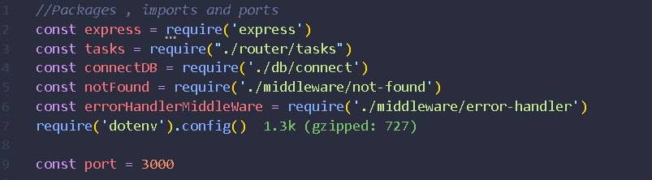

1.express: It is the express package , nothing much to say about it

2.tasks: Contains the routes and pathways, found inside routes folder

3.connectDB: cotains the code to connect to mongodb hosted on mongodb atlas

4.notFound: a middleware to handle the error when a product is search for update , delete or seraching and not found in the database

5.errorHandlerMiddleware: custom error handling middleware that manages error across the app

6.require(‘dotenv’).config() : from dotenv npm pakage provides link to the .env file that contains the link to mongo-atlas

7.port: Port no the server is accepting request on

Server Start and DB connect:

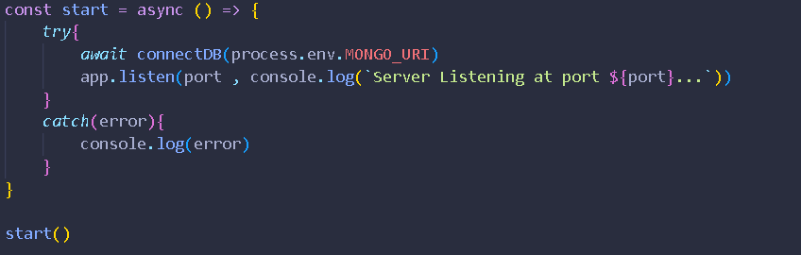

As seen in the images above the function start is used to connect to mongodb.

process is a global variable of nodejs

env is the .env file and Mongo_URI contains the link to mongodb

As the function is written the server only starts when the it is connected to DB